React

**ListofPlayers.js**

import React from 'react';

const ListofPlayers = () => {

const players = [

{ name: 'Virat', score: 95 },

{ name: 'Rohit', score: 88 },

{ name: 'Rahul', score: 45 },

{ name: 'Jadeja', score: 67 },

{ name: 'Bumrah', score: 78 },

{ name: 'Dhoni', score: 50 },

{ name: 'Shami', score: 66 },

{ name: 'Ashwin', score: 85 },

{ name: 'Surya', score: 30 },

{ name: 'Gill', score: 74 },

{ name: 'Pant', score: 55 }

];

const playerList = players.map((player, index) => (

<li key={index}>{player.name} - {player.score}</li>

));

const lowScorers = players.filter(p => p.score < 70);

return (

<div>

<h2>All Players:</h2>

<ul>{playerList}</ul>

<h3>Players Scoring Below 70:</h3>

<ul>

{lowScorers.map((p, i) => (

<li key={i}>{p.name} - {p.score}</li>

))}

</ul>

</div>

);

};

export default ListofPlayers;

**IndianPlayers.js**

import React from 'react';

const IndianPlayers = () => {

const oddPlayers = ['Virat', 'Rahul', 'Dhoni', 'Ashwin', 'Gill'];

const evenPlayers = ['Rohit', 'Jadeja', 'Bumrah', 'Shami', 'Pant', 'Surya'];

const [p1, p2, p3] = oddPlayers;

const [q1, q2, q3] = evenPlayers;

const T20players = ['Virat', 'Rohit', 'Pant'];

const RanjiTrophyPlayers = ['Pujara', 'Rahane'];

const allPlayers = [...T20players, ...RanjiTrophyPlayers];

return (

<div>

<h2>Odd Team Players</h2>

<ul>

<li>{p1}</li>

<li>{p2}</li>

<li>{p3}</li>

</ul>

<h2>Even Team Players</h2>

<ul>

<li>{q1}</li>

<li>{q2}</li>

<li>{q3}</li>

</ul>

<h3>Merged Player List (T20 + Ranji)</h3>

<ul>

{allPlayers.map((player, i) => <li key={i}>{player}</li>)}

</ul>

</div>

);

};

export default IndianPlayers;

**App.js**

import React from 'react';

import ListofPlayers from './ListofPlayers';

import IndianPlayers from './IndianPlayers';

function App() {

const flag = true; // Change to false to test the other view

return (

<div className="App">

<h1>Cricket App</h1>

{flag ? <ListofPlayers /> : <IndianPlayers />}

</div>

);

}

export default App;

**Output:**

**If True**

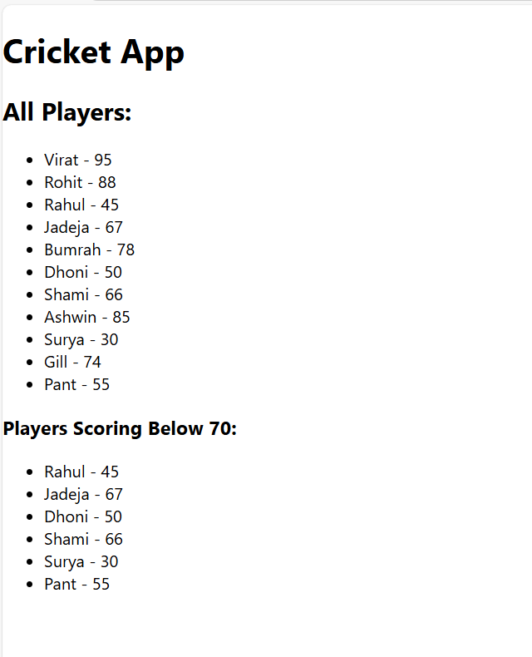

If false

